Mathematical Proofs

Chapter 3 – Sets (Exercise solutions)

Lasse Hammer Priebe

2016

Table of Contents

Section 1: Describing a Set 3

Exercises 3

Section 2: Subsets 4

Exercises 4

Section 3: Set Operations 6

Exercises 6

Section 4: Indexed Collections of Sets 10

Exercises 10

Section 5: Partitions of Sets 12

Exercises 12

## Section 1: Describing a Set

### Exercises

1. Which of the following are sets?
   1. 1, 2, 3 Not a set
   2. {1, 2}, 3 Not a set
   3. {{1}, 2}, 3 Not a set
   4. {1, {2,}, 3} Set
   5. {1, 2, a, b} Set
2. Let . Describe each of the following sets as , where p(x) is some condition on x.
3. Determine the cardinality of each of the following sets:
4. Write each of the following sets by listing its elements within braces.
5. Write each of the following sets in the form , where p(x) is a property concerning x.
6. The set can be described by listing its elements, namely . List the elements of the following sets in a similar manner.
7. The set of even integers can be described by means of a defining condition by . Describe the following sets in a similar manner.
8. Let .
   1. Describe the set A by listing its elements.
   2. Give an example of three elements that belong to B but do not belong to A.
   3. Describe the set C by listing its elements.
   4. Describe the set D in another manner.
   5. Determine the cardinality of the sets A, C and D.
9. For , let and . Determine C.
   1. (because

## Section 2: Subsets

### Exercises

1. Give examples of three sets A, B and C such that
2. Let (a, b) be an open interval of real numbers and let . Describe an open interval I centered at c such that .
   1. Let , then
3. Which of the following sets are equal?
   1. Conclusion: The elements in are equal and C is on its own.
4. For a universal set and two sets and , draw a Venn diagram that represents these sets

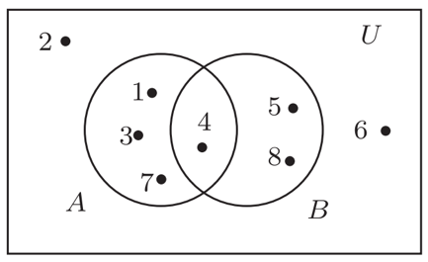

1. Find for
2. Find for .
3. Find and its cardinality.
4. Find and for .
5. For , determine .
6. Give an example of a set S such that
7. Determine whether the following statements are true or false.
   1. If
      1. **False**, e.g.
   2. If A, B and C are sets such that thencan be .
      1. **True**. If , then the cardinality of . Since is a proper subset of C, C must at least have a cardinality of 5.
   3. If a set B has one more element than a set A, then has at least two more elements than.
      1. **False**, if then and (It is true if )
   4. If four sets A, B, C and D are subsets of {1, 2, 3} such that , then at least two of these sets are equal.
      1. **True**. Different combinations of {1, 2, 3} with cardinality 2: . Namely {1, 2}, {1, 3} and {2, 3}.
8. Three subsets A, B and C of have the same cardinality. Furthermore,
   1. 1 belongs to A and B but not to C.
   2. 2 belongs to A and C but not to B.
   3. 3 belongs to A and exactly one of B and C.
   4. 4 belongs to an even number of A, B and C.
   5. 5 belongs to an odd number of A, B and C.
   6. The sums of the elements in two of the sets A, B and C differ by 1.
   7. What is B?

## Section 3: Set Operations

### Exercises

1. Let be the universal set, , and . Determine the following.
2. Give examples of two sets A and B such that . Draw the accompanying Venn diagram.

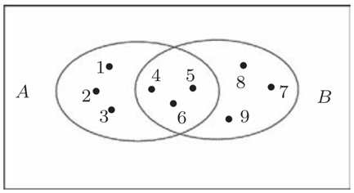

1. Give examples of three sets A, B and C such that but
2. Give examples of three sets A, B and C such that
3. Let U be a universal set and let A and B be two subsets of U. Draw a Venn diagram for each of the following sets.









1. Give an example of a universal set U, two sets A and B and accompanying Venn diagram such that

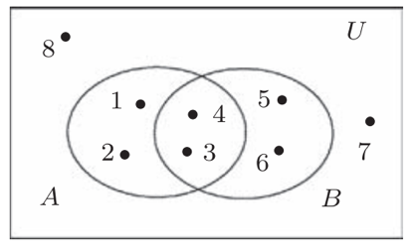

1. Let A, B and C be nonempty subsets of a universal set U. Draw a Venn diagram for each of the following set operations.

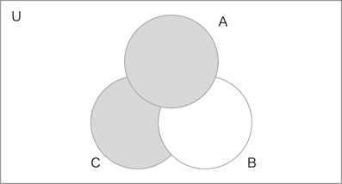

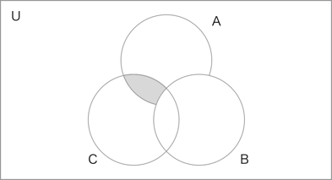

1. Let .
   1. Determine which of the following are elements of A:
      1. are elements of A
   2. Determine
   3. Determine which of the following are subsets of A:
      1. are subsets of A

For (d)-(i), determine the indicated sets.

1. Let .
   1. Express A, B and C using interval notation.
2. Give an example of four different sets A, B, C and D such that (1) and and (2) if B and C are interchanged and are interchanged, then we get the same result (.
3. Give an example of four different subsets A, B, C and D of {1, 2, 3, 4} such that all intersections of two subsets are different.
4. Give an example of two nonempty sets A and B such that is the power set of some set.
5. Give examples of two subsets A and B of {1, 2, 3} such that all of the following sets are different: .
   1. Then the different results are:
6. Give examples of a universal set U and sets A, B and C such that each of the following sets contains exactly one element: . Draw the accompanying Venn diagram.
   1. Then the different results are: .

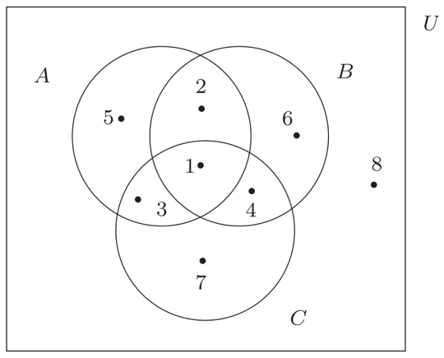

## Section 4: Indexed Collections of Sets

### Exercises

1. For a real number r, define to be the interval Let . Determine and .
2. Let Determine .
3. For a real number r, define as the closed interval and as the interval . For , determine
   1. and
   2. and
   3. and
4. Let be the set consisting of the letters of the alphabet. For , let consist of and the two letters that follow it, where and . Find a set of smallest cardinality such that . Explain why your set S has the required properties.
5. For . Determine the following:
6. For each of the following, find an indexed collection of distinct sets (that is, no two sets are equal) satisfying the given conditions.
   1. and
   2. and
7. For each of the following collections of sets, define a set for each such that the indexed collection is precisely the given collection of sets. Then find both the union and intersection of the indexed collections of sets.
   * 1. where
     2. where
8. For , let . Determine and .
9. Each of the following sets is a subset of .
   1. Find a set such that for every two distinct elements and is maximum.
10. For , let . Determine .

## Section 5: Partitions of Sets

### Exercises

1. Which of the following are partitions of ? For each collection of subsets that is not a partition of A, explain your answer.
   1. **This is a partition of A**
   2. ; This is not a partition, because
   3. ; **This is a partition of A**
   4. ; This is not a partition because
   5. This is not a partition because b is in and in .
2. Which of the following sets are partitions of ?
   1. ; This is not a partition since the element 4 belongs to no element of .
   2. ; **This is a partition**
   3. ; This is not a partition, since 2, 3 and 4 appear in multiple elements of .
   4. ; This is not a partition, since it isn’t a collection of subsets of A, but the set A itself.
3. Let . Give an example of a partition S of A such that
4. Give an example of a set and two disjoint partitions and of A with
5. Give an example of a partition of into three subsets.
6. Give an example of a partition of into three subsets.
7. Give an example of three sets such that is a partition of A, is a partition of and .
   1. Then .
8. Give an example of a partition of into four subsets.
9. Let Give an example of a partition S of A satisfying the following requirements: (i) , (ii) there is a subset T of S such that and (iii) there is no element such that .
10. A set S is partitioned into two subsets . This produces a partition of S where and so . One of the sets in is then partitioned into two subsets, producing a partition of S with . A total of sets in are partitioned into two new subsets each, producing a partition of S. Next, a total of sets in are partitioned into two new subsets, each producing a partition of S. This is continued until partition of S. What is ?
    1. (since subsets are partitioned into two new subsets each)
    2. (since subsets are partitioned into two new subsets each)
    3. (since subsets are partitioned into two new subsets each)
    4. (since subsets are partitioned into two new subsets each)
11. We mentioned that there are three ways that a collection S of subsets of a nonempty set A is defined to be a partition of A. **Definition 1**: The collection S consists of pairwise disjoint nonempty subsets of A and every element of A belongs to a subset in S**. Definition 2**: The collection S consists of nonempty subsets of A and every element of A belongs to exactly one subset in S. **Definition 3**: The collection S consists of subsets of A satisfying the three properties (1) every subset in S is nonempty, (2) every two subsets of A are equal or disjoint and (3) the union of all subsets in S is A.
    1. Show that any collection S of subsets of A satisfying Definition 1 satisfies Definition 2.
       1. In definition 1, the subsets of A in S are pairwise disjoint and every element of A belongs to a subset in S.
       2. Since the subsets are pairwise disjoint, each element of A is contained in only one subset of S.
       3. This is the same as saying, each element of A belongs to exactly one subset in S, which is the premise of definition 2.
    2. Show that any collection S of subsets of A satisfying Definition 2 satisfies Definition 3.
       1. In definition 3, the union of all subsets in S is A. Thus any element x can be found in a subset of S.
       2. Definition 3 also states that the subsets of S must be pairwise disjoint, which together with previous statement implies that and every element of A belongs to exactly one subset in S.
    3. Show that any collection S of subsets of A satisfying Definition 3 satisfies Definition 1.
       1. In definition 3, the union of all subsets in S is A. Thus any element x can be found in a subset of S. This is the same as stated in definition 1: every element of A belongs to a subset in S.
       2. Definition 1 also states: the collection S consists of pairwise disjoint nonempty subsets of A. This is the same as in definition 3: every subset in S is nonempty and every two subsets of A are equal or disjoint.